2. Methodology

2.1 Study Design
This study employs a cross-sectional, mixed-methods design to assess the current situation of complementary feeding practices in Bangladesh and to examine the key drivers and barriers influencing optimal feeding among children aged 6–23 months. The study uses both quantitative surveys and qualitative methods, including Focus Group Discussions (FGDs), Key Informant Interviews (KIIs), and reviews of relevant literature and policy documents. The study was conducted nationwide across all eight administrative divisions of Bangladesh. A structured sampling design was applied, with multiple locations selected within each division to ensure national representativeness.

2.2 Study Area and Period
The study was implemented across the eight divisions of Bangladesh Dhaka, Chattogram, Khulna, Rajshahi, Rangpur, Sylhet, Mymensingh, and Barishal. Eight distrcit was randomly selected from these eight divisions (figure 2.1). From each district three upazilas were selected including Sadar upazila. Selected upazilas were Dhaka (DNCC, DSCC, Keraniganj, Savar); Barishal (Barishal Sadar, Banaripara, Wazirpur); Sherpur (Sherpur Sadar, Nakla, Sreebardi); Satkhira (Satkhira Sadar, Tala, Debhata); Habiganj (Habiganj Sadar, Chunarughat, Bahubal); Chapainawabganj (Chapainawabganj Sadar, Nachol, Shibganj); Dinajpur (Dinajpur Sadar, Chirirbandar, Birol); and Chittagong (CCC, Hathazari, Boalkhali). The study was conducted between June to October 2025.

2.3 Study Participants
The study targets multiple participant groups to capture perspectives at the household, community, service delivery, and policy levels. For the quantitative component, data on child feeding practices and related factors were collected from the adult caregivers of children aged 6–23 months. Data collection was conducted at health-related congregation points, including hospitals, community clinics, Upazila Health Complexes, EPI outreach sites, and surrounding community locations. Eligible caregivers who were present at the time of data collection and provided informed consent were included in the survey.
For the qualitative component, Focus Group Discussions (FGDs) were conducted with caregivers of children aged 6–23 months who expressed willingness to participate. Key Informant Interviews (KIIs) were conducted with health service providers, health managers, and relevant policymakers. In cases where the designated officials were unavailable, interviews were conducted with appropriately nominated personnel.

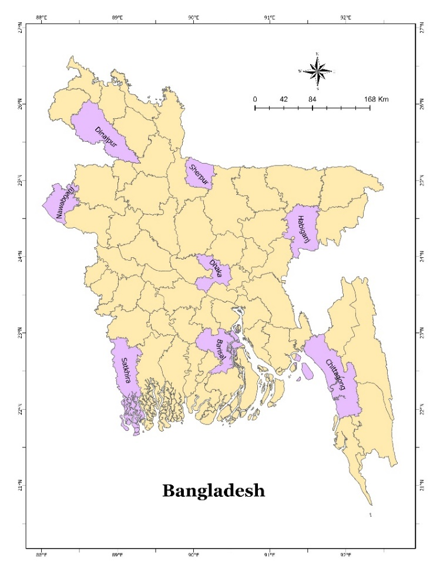
Figure 2.1: Study site

2.4 Sample Size and Sampling Strategy
The study followed a complex sampling approach, combining stratified multistage random sampling and convenience sampling techniques. For the quantitative component, at first, upazilas are selected from eight different districts of each division. Health-related congregation sites from these upazilas served as the primary sampling units. Samples were proportionately allocated across all eight administrative divisions to ensure national representativeness. Within each upazila, health congregation sites were selected using a multistage random sampling procedure. Finally, caregivers of children aged 6–23 months were selected as the secondary sampling unit using purposive sampling from the selected sites. Caregivers who met the eligibility criteria were present at the time of data collection, and provided informed consent were included in the survey.
To ensure adequate qualitative coverage across study sites, a preliminary target of two Key Informant Interviews (KIIs) and one Focus Group Discussion (FGD) was set for each selected upazilas. This approach provided sufficient depth to explore contextual factors influencing IYCF practices. The planned sample distribution is presented in detail in Table 2.1.
Table 2.1: Sample distribution
Sl. | Division | Total Upazila | Interview with caregivers | FGD with caregivers | KII with health managers & policymakers
1 | Dhaka | 4 | 64 | 4 | 8
2 | Sylhet | 3 | 48 | 3 | 6
3 | Rajshahi | 3 | 48 | 3 | 6
4 | Mymensingh | 3 | 48 | 3 | 6
5 | Chattogram | 3 | 48 | 3 | 6
6 | Khulna | 3 | 48 | 3 | 6
7 | Barishal | 3 | 48 | 3 | 6
8 | Rangpur | 3 | 48 | 3 | 6
Total |  | 25 | 400 | 25 | 50
Finally, 405 quantitative observations were collected across the selected locations. A total of 25 FGDs were conducted as planned; however, only 37 KIIs with health managers were completed due to access and consent constraints.

2.5 Data Collection Tools
This study employed a mixed methods approach, incorporating both quantitative and qualitative data collection. For the quantitative part, a structured questionnaire was developed to collect data on general information, demographic and socioeconomic characteristics, access to mass media and nutrition services, parental characteristics, child information, household dietary practices, child feeding practices, and barriers to optimal complementary feeding practices. Data were collected from the caregivers of children aged 6–23 months. The questionnaire consisted primarily of close-ended questions, with a limited number of open-ended questions included where necessary. All instruments were designed to align with and adequately address the objectives of the study.
For the qualitative component, semi structured interview and discussion guidelines were developed for each category of participants. These guidelines were informed by the study objectives and were intended to complement and contextualize the quantitative findings. Key thematic areas included caregivers’ knowledge, attitudes, and practices related to infant and young child feeding; barriers to accessing adequate and diverse complementary foods; coverage, quality, and affordability of existing nutrition and health programs and services; stakeholders’ perspectives on child feeding practices and child health; and geographical variations in feeding practices. These themes were explored from multiple perspectives during qualitative interviews and focus group discussions with different participant groups. Collectively, the quantitative questionnaires and qualitative guidelines ensured comprehensive coverage of all study objectives.

2.6 Enumerator Recruitment and Training
Enumerators were recruited through an open call for applications. Applicants meeting the eligibility criteria were shortlisted and subsequently selected through an interview process. Priority was given to candidates with an academic background in community nutrition and previous experience in field-based data collection. A five-day training program was conducted before the initiation of data collection. The training began with an overview of the study objectives, design, and theoretical framework. All questionnaire items were explained in detail, and paper-based questionnaires were distributed to support comprehensive understanding.
To enhance interviewing skills and promote standardization in data collection, enumerators participated in practical sessions, including peer-to-peer mock interviews. As the survey was administered using Kobo Toolbox, dedicated hands-on training was provided on the use of the Kobo Collect application and online data collection procedures. Prior to the completion of training, enumerators engaged in supervised field practice in real community settings. Enumerator performance during these sessions was closely monitored, and constructive feedback was provided to identify and address any gaps. This process helped to ensure data quality and consistency before the full-scale field implementation began.

2.7 Pretesting of the data collection tools
All data collection tools were piloted in a hospital setting prior to field implementation. The pretest was conducted by a selected group of trained enumerators under the direct supervision of research assistants and research associates. During this phase, both quantitative and qualitative data were gathered to examine the clarity, contextual relevance, feasibility, validity, and reliability of the tools, as well as their consistency with the study objectives. The pretest data were systematically reviewed, and structured feedback was collected from enumerators regarding their experiences, understanding of the questionnaires, and operational challenges. Based on these insights, revisions were made to improve question phrasing, response categories, and overall data collection procedures.

2.8 Data Collection Procedures
Based on the predefined sampling framework, field teams comprising trained enumerators and supervised by a research assistant visited the selected health congregation sites. Formal permission was sought from the relevant authorities prior to initiating data collection. Once approval was obtained, quantitative enumeration activities were carried out. Eligible caregivers present at the site on the day of data collection were recruited using a convenience sampling approach. Quantitative data collection was conducted using the Kobo Toolbox digital platform. Survey instruments were programmed into Kobo forms with standardized variable coding and built-in skip logic to enhance data quality and minimize entry errors. Data was collected by enumerators and research assistants using smartphones installed with the Kobo-Collect application. A secure, centralized server system enabled authorized personnel to access assigned questionnaires and upload completed forms in real time, ensuring timely and organized data management.
Qualitative data was obtained through in-person interviews and group discussions. Prior to participation, informed consent was obtained from all respondents. All qualitative sessions were audio recorded to ensure accuracy during transcription. Audio recordings were transferred daily to a designated secure server to support systematic data storage and subsequent qualitative analysis.

2.9 Quality Control and Assurance
Before the field implementation, all study instruments underwent a careful review and pretesting to evaluate their clarity, contextual suitability, and consistency with the study objectives. Findings from the pretesting phase informed revisions to the tools. The finalized questionnaires were then digitized using the Kobo Toolbox platform and incorporated automated validation rules, logical constraints, and skip patterns to reduce entry errors and missing data. Field data collection was implemented under continuous supervision by trained research assistants. Supervisory activities included routine field visits, daily observation of interviews, and spot checks to ensure strict adherence to standardized data collection protocols. Any deviations or errors identified during supervision were promptly communicated to enumerators, and immediate corrective instructions were provided.
When delays, inconsistencies, or performance-related challenges were identified, refresher training sessions were organized to reinforce field procedures and maintain data quality standards. Data submitted through the Kobo platform were reviewed daily via a centralized server to assess completeness and internal consistency. In cases where discrepancies were detected, enumerators were contacted without delay to seek clarification or make necessary corrections. Server access was limited to authorized personnel to safeguard data integrity and confidentiality. For qualitative components, interviewers followed standardized semi-structured guides to ensure uniform implementation across interviews and group discussions. All transcripts were cross-checked against the original audio recordings to confirm accuracy. Regular debriefing meetings were conducted with the qualitative research team to address emerging issues and ensure consistent application of qualitative data collection procedures.

2.10 Data Management and Analysis
Upon completion of field data collection, quantitative datasets were extracted from the Kobo Toolbox server in Microsoft Excel format and subsequently transferred to SPSS for data management and analysis. Data cleaning procedures included systematic checks for missing values, outliers, and data entry errors. Due to the incorporation of automated validation rules, logical checks, and skip patterns within the electronic questionnaires, data inconsistencies and missing observations were minimal.
Following data cleaning, the finalized dataset was prepared for statistical analysis. Household socioeconomic status was measured by constructing a wealth index in accordance with the Demographic and Health Survey methodology (Rutstein, 2022). Several composite indicators including Infant and Young Child Feeding (IYCF) indicators (UNICEF & WHO, 2021), child food poverty measures (UNICEF, 2024), and the Early Childhood Food Insecurity Experience Scale (UNICEF, 2025) were derived following standard guidelines.
Descriptive statistics were used to summarize the data, with categorical variables presented as frequencies and percentages. Qualitative data were transcribed verbatim and analyzed using qualitative data analysis software. A thematic analysis approach was employed, integrating both deductive and inductive coding strategies. Predefined themes based on the study objectives guided the initial coding, while additional themes and subthemes emerged iteratively during analysis. Final themes were reviewed, refined, and integrated to complement and contextualize the quantitative findings.

2.11 Ethics

2.11.1 Ethical approval
Ethical approval for the study was obtained prior to the initiation of field activities from the Institutional Review Board of the Institute of Health Economics, University of Dhaka. The study protocol was reviewed in detail, and ethical clearance was granted upon completion of necessary revisions (Ref. No. IHE/IRB/DU/14/2025/Final).

2.11.2 Ethical considerations during and after data collection
All selected participants were provided with detailed information regarding the study objectives, procedures, and potential risks and benefits. Oral informed consent was obtained before data collection. Respondents were clearly informed that participation was voluntary and that they could withdraw from the study at any time or choose not to answer specific questions without any negative consequences. Privacy and confidentiality were maintained throughout, and interviews were conducted in a respectful and non-coercive manner.
All data were anonymized prior to analysis. Findings are reported in aggregate form to prevent identification of individuals or communities. Data are used solely for research purposes and stored securely for a defined period before disposal.

2.11.3 Data protection and confidentiality
All data were collected and stored in accordance with strict confidentiality protocols. Personal identifiers were minimized, and unique codes were assigned to participants to ensure anonymity. Digital data were securely stored on password-protected servers with access limited to authorized research team members. Data transmission was encrypted, and all data collection devices were secured. Audio recordings were stored separately, and all identifying information was removed during transcription. Only anonymized data were used for analysis and reporting. Data will be securely archived and destroyed in accordance with institutional guidelines.

2.11.4 Referral mechanisms
As most data were collected at EPI outreach sites and community clinics, no formal referral mechanism was established. However, participants requiring health or nutrition support were informally referred to nearby health facilities. Enumerators provided information on available nutrition and health services but did not offer clinical advice. Cases requiring urgent attention were directed to qualified healthcare providers.

